1. Download and install an SD card formatter such as [SD Memory Card Formatter](https://www.sdcard.org/downloads/formatter_4/index.html) or [PiBakery](http://www.pibakery.org/download.html" \t "_blank). Insert the SD card into your computer. Start the program and choose the drive where you have inserted your SD card. You can perform a quick format of the SD card.
2. Download the [Raspbian Buster](https://downloads.raspberrypi.org/raspbian/images/raspbian-2019-07-12/) operating system as a zip file.
3. Using an SD card-writing tool (such as [Etcher](https://etcher.io/)), follow the tool's instructions to flash the downloaded zip file onto the SD card. Because the operating system image is large, this step might take some time. Eject your SD card from your computer, and insert the microSD card into your Raspberry Pi.
4. For the first boot, we recommend that you connect the Raspberry Pi to a monitor (through HDMI), a keyboard, and a mouse. Next, connect your Pi to a micro USB power source and the Raspbian operating system should start up.
5. You might want to configure the Pi's keyboard layout before you continue. To do so, choose the Raspberry icon in the upper-right, choose **Preferences** and then choose **Mouse and Keyboard Settings**. Next, on the **Keyboard** tab, choose **Keyboard Layout**, and then choose an appropriate keyboard variant.
6. Next, [connect your Raspberry Pi to the internet through a Wi-Fi network](https://www.raspberrypi.org/documentation/configuration/wireless/desktop.md) or an Ethernet cable.

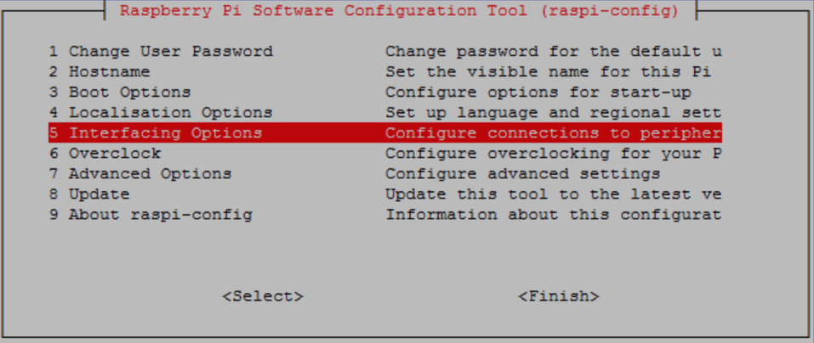

Scroll down and choose **Interfacing Options** and then choose **P2 SSH**. When prompted, choose **Yes**. (Use the **Tab** key followed by**Enter**). SSH should now be enabled. Choose **OK**. Use the **Tab** key to choose **Finish** and then press **Enter**. If the Raspberry Pi